Cabo Verde

## Respect for rule of law (ROL) data

The data set shows the data on the respect of the rule of law for the country.

## # A tibble: 19 x 5  
## country iso3c date ruleOfLaw ruleOfLawCategory4   
## <chr> <chr> <dbl> <dbl> <chr>   
## 1 Cabo Verde CPV 1996 1.04 ROL highly respected   
## 2 Cabo Verde CPV 1998 0.831 ROL moderately respected  
## 3 Cabo Verde CPV 2000 0.782 ROL moderately respected  
## 4 Cabo Verde CPV 2002 0.341 ROL moderately respected  
## 5 Cabo Verde CPV 2003 0.294 ROL moderately respected  
## 6 Cabo Verde CPV 2004 0.357 ROL moderately respected  
## 7 Cabo Verde CPV 2005 0.402 ROL moderately respected  
## 8 Cabo Verde CPV 2006 0.653 ROL moderately respected  
## 9 Cabo Verde CPV 2007 0.628 ROL moderately respected  
## 10 Cabo Verde CPV 2008 0.576 ROL moderately respected  
## 11 Cabo Verde CPV 2009 0.536 ROL moderately respected  
## 12 Cabo Verde CPV 2010 0.475 ROL moderately respected  
## 13 Cabo Verde CPV 2011 0.511 ROL moderately respected  
## 14 Cabo Verde CPV 2012 0.524 ROL moderately respected  
## 15 Cabo Verde CPV 2013 0.536 ROL moderately respected  
## 16 Cabo Verde CPV 2014 0.635 ROL moderately respected  
## 17 Cabo Verde CPV 2015 0.590 ROL moderately respected  
## 18 Cabo Verde CPV 2016 0.346 ROL moderately respected  
## 19 Cabo Verde CPV 2017 0.413 ROL moderately respected

## Respect for rule of law (ROL) trend

The plot shows the trend of the respect for the rule of law for the country.

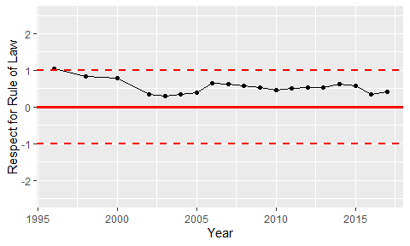

Trend of the Respect for the Rule of Law